

**Ourimbah Public School**

Flying Start Transition to School Program

for Kindergarten Children

2023

Children enrolling in Kindergarten at Ourimbah Public School for 2023 are invited to attend a Kindergarten orientation program. The program is held over the following 5 sessions.

**Monday, 22 August 2022**

***Parent Information Night***

***5:00pm – 6:30pm School Hall***

Overview of the transition to school program and guest speakers from the school community.

**Friday, 25 November 2022**

***School Visit 3 (times to be advised)***

* Kindergarten groups and activities

***Parent Information Session (times to be advised)***

* School Curriculum and stages of learning
* Morning tea

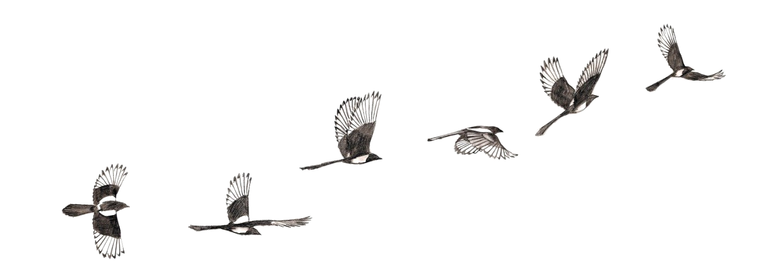

**Friday, 2 December 2022**

***School Visit 4 (times to be advised)***

* Kindergarten groups and activities

***Parent Information Session (times to be advised)***

* RAP Trail Tour
* Celebration picnic with children. Morning tea provided by P&C.

**Friday, 11 November 2022**

***School Visit (times to be advised)***

Parents and children

* School tour
* Classroom visit

**Friday, 18 November 2022**

***School Visit 2 (times to be advised)***

* Kindergarten groups and activities

***Parent Information Session (times to be advised)***

* School welfare procedures
* Morning tea

Enrolment forms may be accessed on our school website [www.ourimbah-p.schools.nsw.nsw.gov.au](http://www.ourimbah-p.schools.nsw.nsw.gov.au). If you have any enquiries you can contact our Administration Office between 8.30 am and 3.00 pm (Monday to Friday) on (02) 4362 1033 or email us at [Ourimbah-p.school@det.nsw.edu.au](mailto:Ourimbah-p.school@det.nsw.edu.au).

